Database Migration

🌟 Definition
# Source: AI Source: Provided by: [Data Path: Persons Table -> ID Column: 1, Name_En Column: Motasem Essam] -> From: [ChatGPT] on [6/7/2026]
Database Migration is the process of moving, modifying, upgrading, or transforming a database from one state to another.
The migration may involve:
- Changing database structure (schema)
- Moving data
- Upgrading database versions
- Switching database systems
- Moving databases to new servers or cloud platforms

🎯 Purpose
# Source: AI Source: Provided by: [Data Path: Persons Table -> ID Column: 1, Name_En Column: Motasem Essam] -> From: [ChatGPT] on [6/7/2026]
Database migration is performed to:
- Add new features
- Improve performance
- Improve security
- Fix database design issues
- Upgrade technology
- Move to cloud services
- Support application growth

🧠 Simple Definition
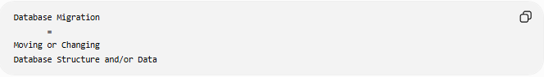
Database Migration
=
Moving or Changing
Database Structure and/or Data

📚 What Can Be Migrated?

1️⃣ Database Schema
# Source: AI Source: Provided by: [Data Path: Persons Table -> ID Column: 1, Name_En Column: Motasem Essam] -> From: [ChatGPT] on [6/7/2026]
Schema means the database structure:
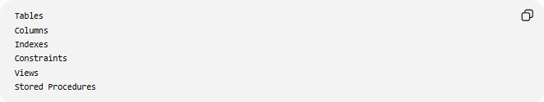
Tables
Columns
Indexes
Constraints
Views
Stored Procedures
Example:
Before
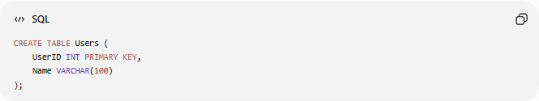
CREATE TABLE Users (
UserID INT PRIMARY KEY,
Name VARCHAR(100)
);

Migration
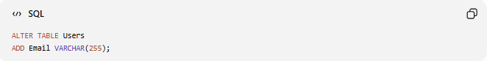
ALTER TABLE Users
ADD Email VARCHAR(255);

After
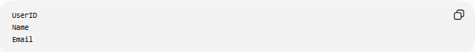
UserID
Name
Email

2️⃣ Database Data
# Source: AI Source: Provided by: [Data Path: Persons Table -> ID Column: 1, Name_En Column: Motasem Essam] -> From: [ChatGPT] on [6/7/2026]
Move records from one location to another.
Example:
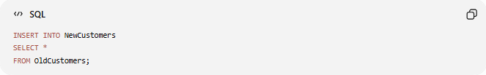
INSERT INTO NewCustomers
SELECT *
FROM OldCustomers;

Process:
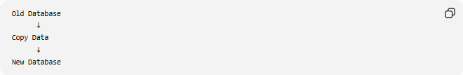
Old Database
↓
Copy Data
↓
New Database

🔍 Types of Database Migration

1. Schema Migration
# Source: AI Source: Provided by: [Data Path: Persons Table -> ID Column: 1, Name_En Column: Motasem Essam] -> From: [ChatGPT] on [6/7/2026]
Changes database structure.
Examples:
- Create table
- Add column
- Remove column
- Add constraint
Example:
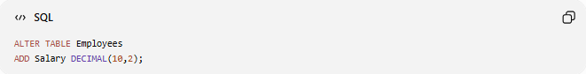
ALTER TABLE Employees
ADD Salary DECIMAL(10,2);

2. Data Migration
# Source: AI Source: Provided by: [Data Path: Persons Table -> ID Column: 1, Name_En Column: Motasem Essam] -> From: [ChatGPT] on [6/7/2026]
Moves data.
Example:
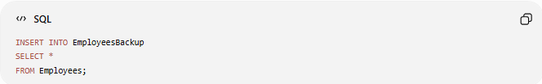
INSERT INTO EmployeesBackup
SELECT *
FROM Employees;

3. Database Platform Migration
Move between database systems.
Example:
MySQL
↓
PostgreSQL
or
SQL Server
↓
Oracle Database
Common reasons:
- Better performance
- Lower licensing costs
- New features

3. Database Platform Migration
# Source: AI Source: Provided by: [Data Path: Persons Table -> ID Column: 1, Name_En Column: Motasem Essam] -> From: [ChatGPT] on [6/7/2026]
Move between database systems.
Example:
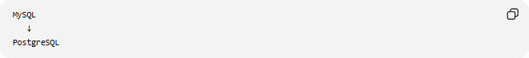
MySQL
↓
PostgreSQL
Or
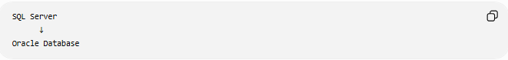
SQL Server
↓
Oracle Database
Common reasons:
- Better performance
- Lower licensing costs
- New features

4. Cloud Database Migration
# Source: AI Source: Provided by: [Data Path: Persons Table -> ID Column: 1, Name_En Column: Motasem Essam] -> From: [ChatGPT] on [6/7/2026]
Move database to cloud.
Example:
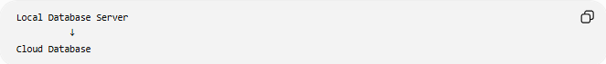
Local Database Server
↓
Cloud Database
Examples of cloud services:
- Amazon Web Services RDS
- Microsoft SQL Database
- Google Cloud SQL

🛠️ Common Database Migration Operations
# Source: AI Source: Provided by: [Data Path: Persons Table -> ID Column: 1, Name_En Column: Motasem Essam] -> From: [ChatGPT] on [6/7/2026]
Create Table
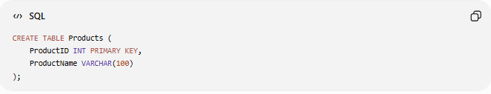
CREATE TABLE Products (
ProductID INT PRIMARY KEY,
ProductName VARCHAR(100)
);

Add Column
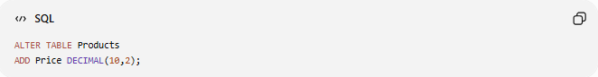
ALTER TABLE Products
ADD Price DECIMAL(10,2);

Modify Column
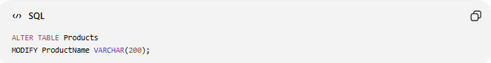
ALTER TABLE Products
MODIFY ProductName VARCHAR(200);

Rename Table
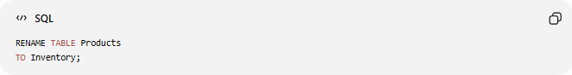
RENAME TABLE Products
TO Inventory;

Copy Data
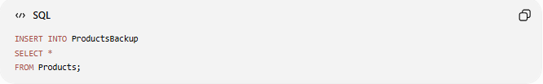
INSERT INTO ProductsBackup
SELECT *
FROM Products;

📊 Real-World Example
# Source: AI Source: Provided by: [Data Path: Persons Table -> ID Column: 1, Name_En Column: Motasem Essam] -> From: [ChatGPT] on [6/7/2026]
E-Commerce Application
Version 1:
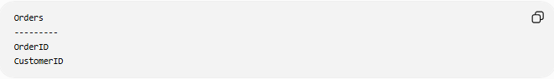
Orders
---------
OrderID
CustomerID

New Requirement:
Track order status.
Migration:
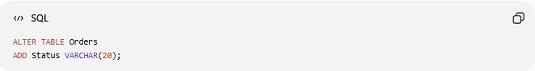
ALTER TABLE Orders
ADD Status VARCHAR(20);

Version 2:
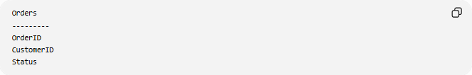
Orders
---------
OrderID
CustomerID
Status
Supported values:
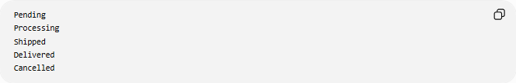
Pending
Processing
Shipped
Delivered
Cancelled

🔄 Migration Lifecycle
# Source: AI Source: Provided by: [Data Path: Persons Table -> ID Column: 1, Name_En Column: Motasem Essam] -> From: [ChatGPT] on [6/7/2026]
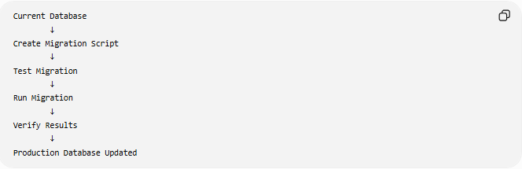
Current Database
↓
Create Migration Script
↓
Test Migration
↓
Run Migration
↓
Verify Results
↓
Production Database Updated

↩️ Rollback
A rollback reverses a migration.
Migration
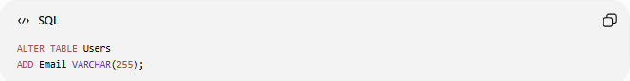
ALTER TABLE Users
ADD Email VARCHAR(255);

Rollback
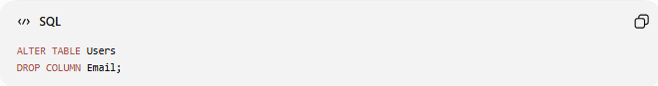
ALTER TABLE Users
DROP COLUMN Email;

Process:
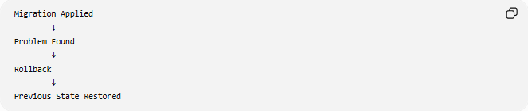
Migration Applied
↓
Problem Found
↓
Rollback
↓
Previous State Restored

⚠️ Risks of Database Migration
# Source: AI Source: Provided by: [Data Path: Persons Table -> ID Column: 1, Name_En Column: Motasem Essam] -> From: [ChatGPT] on [6/7/2026]
Possible issues:
- Data loss
- Downtime
- Broken applications
- Performance problems
- Incompatible SQL syntax
- Corrupted data

✅ Best Practices
# Source: AI Source: Provided by: [Data Path: Persons Table -> ID Column: 1, Name_En Column: Motasem Essam] -> From: [ChatGPT] on [6/7/2026]
Backup First
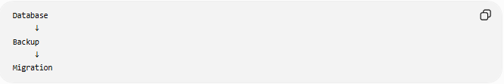
Database
↓
Backup
↓
Migration

Test Before Production
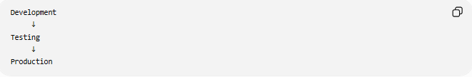
Development
↓
Testing
↓
Production

Use Version Control
Example:
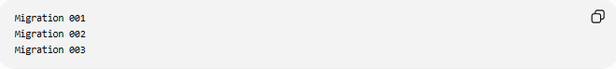
Migration 001
Migration 002
Migration 003

Create Rollback Scripts
Always prepare:
Migration
Rollback

📦 Database Migration Tools
# Source: AI Source: Provided by: [Data Path: Persons Table -> ID Column: 1, Name_En Column: Motasem Essam] -> From: [ChatGPT] on [6/7/2026]
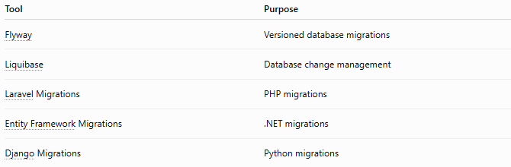
Tool | Purpose
Flyway | Versioned database migrations
Liquibase | Database change management
Laravel Migrations | PHP migrations
Entity Framework Migrations | .NET migrations
Django Migrations | Python migrations

🧠 Simple Analogy
# Source: AI Source: Provided by: [Data Path: Persons Table -> ID Column: 1, Name_En Column: Motasem Essam] -> From: [ChatGPT] on [6/7/2026]
Think of a library.
Before
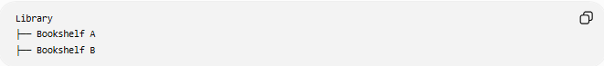
Library
├── Bookshelf A
├── Bookshelf B

Migration
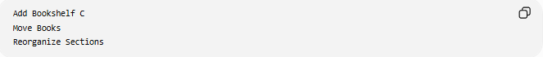
Add Bookshelf C
Move Books
Reorganize Sections

After
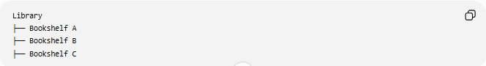
Library
├── Bookshelf A
├── Bookshelf B
├── Bookshelf C
The library still works, but its structure and contents have been improved.

🧭 Summary
# Source: AI Source: Provided by: [Data Path: Persons Table -> ID Column: 1, Name_En Column: Motasem Essam] -> From: [ChatGPT] on [6/7/2026]
Database Migration is the process of changing, moving, upgrading, or transforming a database's structure and/or data. It includes schema migration (tables, columns, constraints), data migration (moving records), platform migration (e.g., MySQL to PostgreSQL), and cloud migration. Database migrations help applications evolve safely while keeping data consistent and available.

